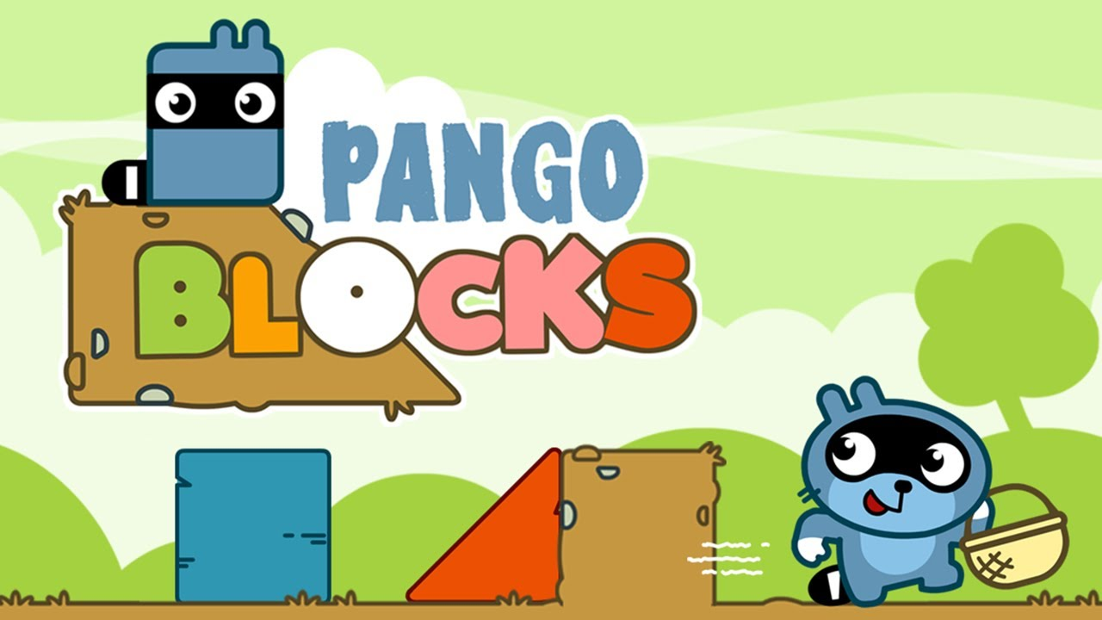

Pango Blocks Remake

# Game Design Document

# 1.0 Overview

This is the Game Design Document of Pango Blocks Remake, a mobile game released in November 2015, developed by Studio Pango.

## 1.1 Concept

Pango Blocks is a logic game suitable for toddlers players, in which they had to choose logic blocks and build the path for Pango the raccoon and help him to reach various items for his friends.

If Pango crosses the screen without falling, he will get an item and move on to the next level.

### Game Mode Single Player

**Genre** Horizontal Puzzle-platform designed for mobile devices

**Platforms** Android/iOS

**Developers and Publisher** Studio Pango

Studio Pango is a French Company Making Games for Kids 3-12 and Making Films For Kids 4-18.

# 2.0 Features

* Logic/educative game
* 5 adventures to discover for your enjoyment
* 40 challenges through 5 universes
* 2 difficulty levels
* Age Target: Perfect for children 3 or older
* No stress and no timer
* A simple, functional application
* Colorful and fully interactive game
* Fully animated with sound and pictures
* Internal parental control
* No in-game purchases and no invasive advertising

## 2.1 Scope

The goal of the game is to help a character who must traverse five stages of eight levels, filled with puzzles and obstacles, forming a path to get him to the key object in the level.

# 3.0 Characters

*Pango* is the main character. He is a blue raccoon.

He has blue fur, black colored eyes, two short ears on his head, a whisker by his left cheek, a black nose, arms and legs, white hands and a black and white tail. He also wears a black mask on his face.

For his classic design, he had fingers on both of his white hands.

## 3.1 Non-Playable Characters

* ***Piggy*** is a little pink pig.

He had the classic appearance of a pig with a lighter-colored nose and a curled tail.

Piggy lives in Germany and wears a brown lederhosen, a traditional leather breeches worn by men.

The player will meet him in the cutscene at the end of stage 1, and then again in the cutscene at the end of stage 2.

* ***Fox*** appears to be a scarlet fox with scarlet fur, two pointy ears, a pointy brown nose.

He has eyelashes on each side of his eyes.

Fox is Pango’s Japanese friend and she wears the typical red kimono.

The player will meet him in the cutscene at the end of stage 3.

* ***Bunny*** is a white rabbit.

He has white fur, black colored eyes with cyan eyeballs, two long ears on her head, a whisker by her left cheek, a black nose with a line connecting to the mouth and sometimes it does not connect to the mouth, arms and legs and a circle shaped tail.

For his classic design, his eyeballs are soap colored like the sky.

Bunny is an archaeologist, he moved to Egypt to further his studies.

He usually wears an explorer outfit and the player will meet her in the cutscene at the end of stage 4.

* ***Squirrel*** is a little squirrel with orange fur, two U shaped ears and a long bushy tail.

He lives his best life in Antarctica, surrounded by sea creatures and polar bears.

The player will meet him in the cutscene at the end of stage 5.

# 4.0 Mechanics

* **Grid**: the game is based on the application of a grid for the placement of geometric blocks, to facilitate the player to the right placement.
* **Cube Placement**: The player has the option of choosing where to place the blocks and which ones to place within the grid. They may decide to not place all the blocks available, as long as a clear path is formed for the character.

## 4.1 Progression

The player has the opportunity to play with increasingly complex levels with various geometric shapes and they must find the best way to place them in the grid, in order to allow the character to proceed along the path.

## 4.2 Core Loop

When the game begins, there are several phases to make up the game loop.

* **Placement Phase**: when the player takes a block from the hand and chooses the cell where to place it, i.e. places it inside the grid.
* **Fall Phase**: when blocks fall from an unaligned position, it is checked if the position is valid i.e. not outside the grid cells and the cell is not occupied by other blocks.

alla fine della fall phase i blocchi che sono rimasti in gioco perché in una valida posizione, verranno resettati alla loro cella d’origine.

* **Objective Phase**: when the player gives input to the character to travel to the object once the best path has been outlined in order to reach the objective
* **Win phase**: when the character has traveled the path constructed by the player and reaches the key object of the level, it makes an animation when the win condition is triggered.
* **Game Over phase**: when the character fails to reach the key object of the level and there is a reset condition of the character's position, with an animation of closing and reopening the level scene.

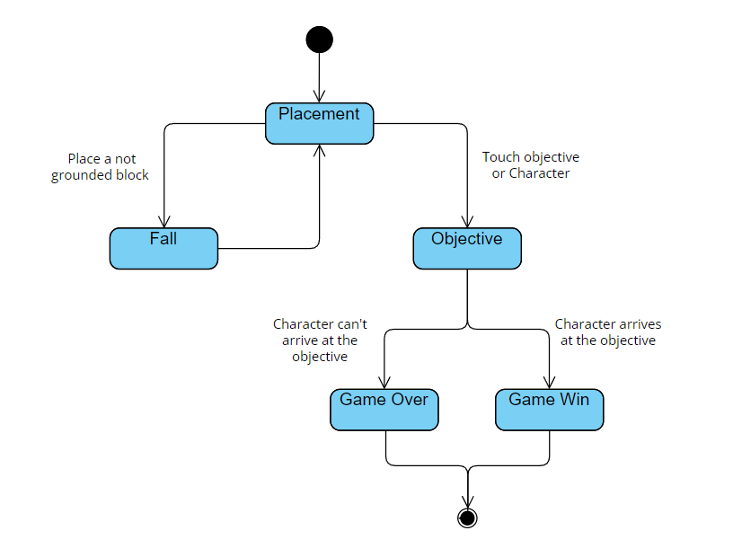

## 4.3 Win/Reset condition

When the player drags the selected blocks by touching the screen, if it has been placed correctly we will have positive feedback that the character has reached the object.

The player can drag any of the provided blocks by touching them and sliding their finger across the screen.

If the blocks have been placed correctly, touching the character or object will trigger the animations and Pango can follow the path and reach the object, clearing the level.

When the player presses the object it makes a widening and shrinking animation.

When the character reaches the target the animation starts where the object stands on top of the character and the animation starts.

* A level reset condition occurs if the player has placed one or more shapes incorrectly or outside the spaces delimited by the grid and gives the input to the character to move, thus triggering movement toward the target.

The character, once the input is received, will perform several animations to let the player know that the path has not been defined correctly.

After this failed attempt, the level transition is replayed and the level restarts.

## 

## 4.3 Levels

Pango Blocks consists of five stages of eight levels, each with its own difficulty and unique design.

### 4.3.1 Level Flow

In Pango Blocks there are different geometric shapes to fit and fit together in order to form a road for the character.

### 4.3.2 Blocks

During the levels of the game, there are physical obstacles such as path interruption or layers of different heights between them that do not allow the character to pass without inserting the blocks in the right position.

### 4.3.3 Block Dragger

Block dragging can be divided into two phases:

* The *first* stage when the screen of the mobile device is pressed (first input).
* The *second* stage when the release of the block to the desired position occurs (actual input screen).

One touch gives two different inputs.

The block follows the position of the player's finger on the device screen with a settable speed of position update from block to finger (almost immediate).

When the player presses on the block, the block will follow the position of the finger according to its position on the screen.

The block will follow the finger position on the screen taking into account the offset position.

When the block is being dragged it will be rendered before the character.

## 4.4 Character Movement

* **Walk**: Character's walk is preset and is triggered by touching the same character or key object in the level selected.
* **Slide**: When there is a triangle-shaped block on the character's tradigit that points downward, the character will do the slide animation (as from a slide at the playground).
* **Climb**: When the character comes across a triangle-shaped block on the way up that points upward simulating a climb, the character will do the climbing animation by showing himself crawling and then getting back up once he is on top.
* **Dizziness**: When the character will move toward along the path, if a blockage has not been placed and a hole remains between one part of the ground and the other, the character will freeze and make an animation with a frightened face looking down,giving the hint that he is suffering from vertigo.
* **Victory**: The character when reaches the object has an exaltation move, making a small jump, making a big smile and showing the key object of the level, all surrounded by stars.

### Fatigued: When the character encounters an obstacle too high along its path such as a block or terrain and collides with it, the players will see it fatigued and tired before the level resets.

### 

### 4.4.1 Character Input

* **Visual feedback**: The character can provide visual feedback on the state of the game, indicating objectives, checkpoints or points of interest through animations and effect sounds.

# 6.0 Gameplay

## 6.1 Player Movement

The character moves only forward, on the X-axis, at a fixed speed (+), once the player gives the input with a touch, touching the object or the character to be reached.

When the player presses the character or object to be reached with his finger on the phone display, the character will move at X speed to reach the target.



The player can give the input to the character even if he has not placed the blocks; in this case the character will still move toward the object following the conformation of the path, but at the first obstacle (such as a road pothole) he encounters in his path the animation will appear and the level will start again.

## 6.2 Game Camera

The camera in this game is a static element that enhances the gameplay experience and helps players solve puzzles and overcome challenges offered in each level.

It offers an orthographic view and is designed to strike a balance between immersion and visibility, adapting to the player's needs while the game is played in landscape.

* **Horizontal View**: The camera primarily provides a horizontal view of the game.

It focuses on the action and environment along the horizontal axis (X-axis), where the character can move from left to right.

* **Puzzle Planning**: The camera is positioned strategically to make important puzzle details visible. This could include highlighting key objects, focusing on areas with environment and elements for progression.
* **Balance between immersion and visibility**:The camera is fixed in the center of the screen and must strike a balance between immersion of the player in the game world and clear visibility of platforms and obstacles.

It is positioned to provide good visibility without interrupting the gameplay experience and keeping the player's attention active.

# 8.0 Level Design

The game is divided into five stages with eight levels per stage.

Each stage has a distinct environment and challenges.

The puzzles involve interactive elements, which are geometric shapes such as squares, triangles, and combined shapes of them in order to create a linear course.

[**Here**](https://docs.google.com/document/u/0/d/1XjlyFf2zmKPDhN57pNpQUhJ-MqOTC5G84V2ja9psZak/edit), in this document, is possible to check the levels present in each stage, divided by difficulty.

## 8.1 Game Grid

The Grid is the core mechanic of Pango Blocks.

It measures **5 high x 8 wide mt** (1mt=1u) and this is where the gameplay is based.

The player can place blocks wherever he or she wishes within the grid cells and cannot go outside the lines.

il blocco deve essere rilasciato sopra la griglia e nel momento in cui viene rilasciato andrà a posizionarsi nella cella più vicina alla posizione del blocco.

The cells in which the player goes to place the block must be unoccupied by other blocks.

Once the blocks are placed, the player is free to move them into the grid’s lines.

If the player doesn’t place the block within the square proposed by the grid, a negative auditory feedback will be heard and the block will return automatically to its initial position, the player’s hand.

## 8.2 Blocks

In Pango Blocks there are different geometric shapes to insert and fit together in order to form a road for the character

* **Blue Square**

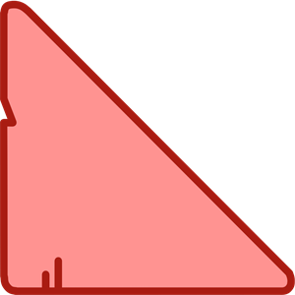

* **Pink Triangle**

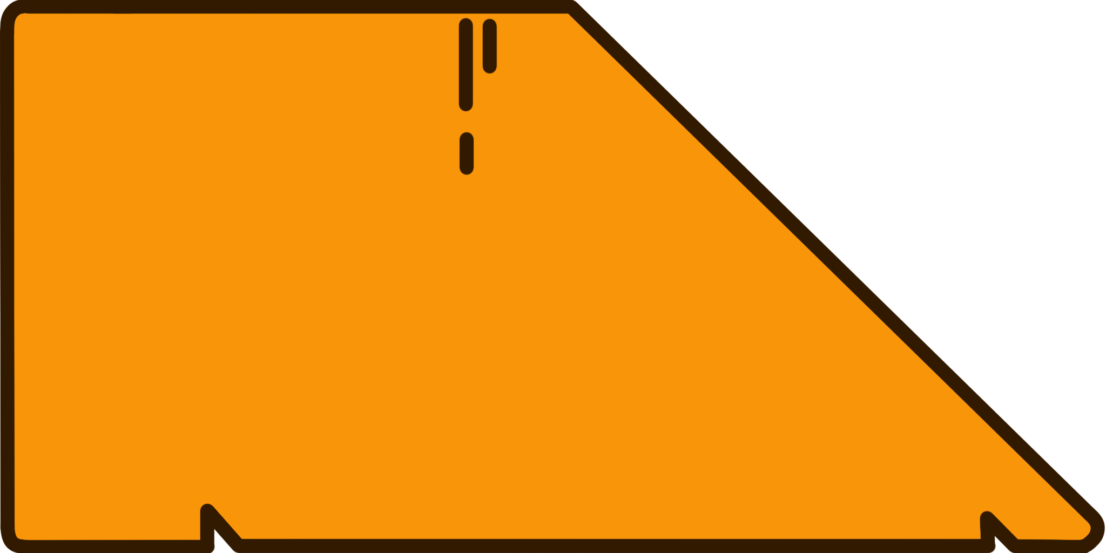

* **Orange Trapezoid**

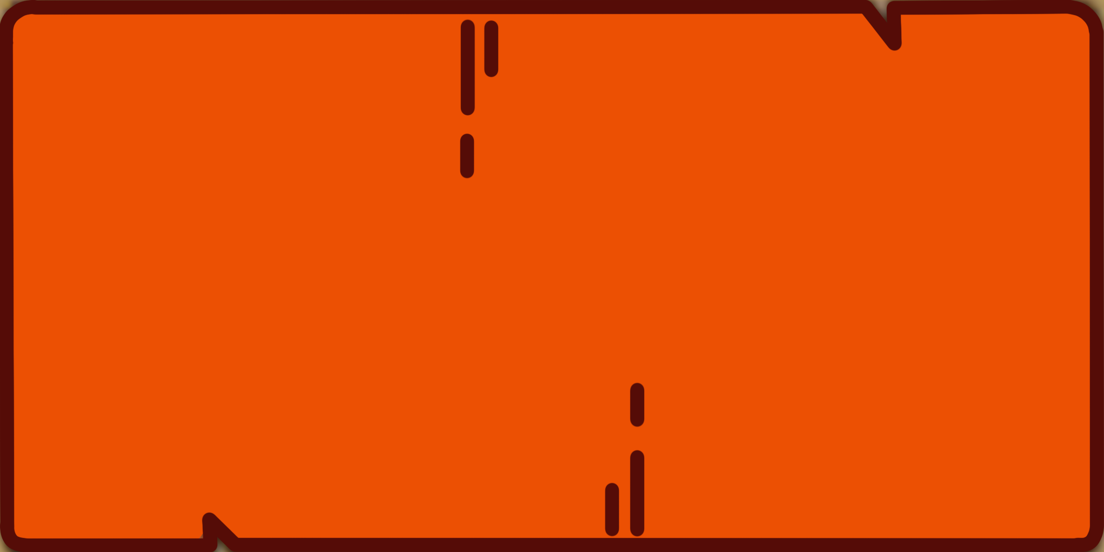

* **Red Rectangle**

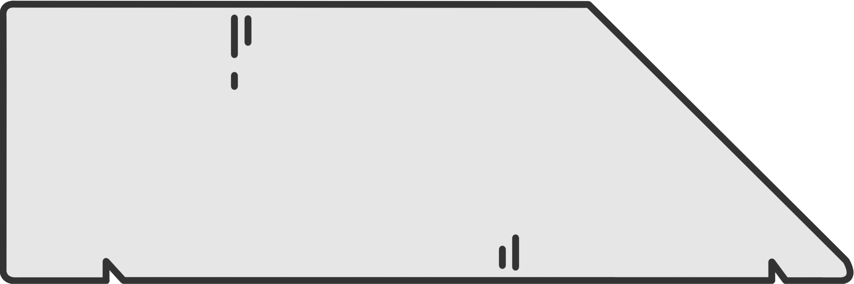

* **White Trapezoid**

These blocks are present in every level.

For each level there are certain predefined shapes that can only vary if there is a change in difficulty.

Quando il blocco cade non collide con il personaggio, ma se la cella in cui si trova il personaggio è occupata solamente dal personaggio stesso, non collide ma torna nella mano del giocatore.

## 8.3 Player’s Hand

The player hand is a settable space (spacing) where the blocks the player needs at each level start are generated.

It can contain more blocks than necessary to give the player more choice in how to build the path for the character and reason about the shapes.

The player can move the blocks within his or her hand and stack them on top of each other.

When the position is invalid, that is, when the block cannot be placed because the cell is occupied or is outside the grid, the block will move with a certain speed (+) in the player's hand and will not be interacted with or touched in the process.

When blocks occupy an invalid position in the game, their position is reset and a lerp starts from the block position to the last valid position in the player's hand.

## 8.4 Items

In each level of the game there is one item to collect, and once all the items of the stage are collected, the cutscene will play.

### 

## **8.5 Stages**

A stage is a set of eight levels that share a purpose and an artistic theme.

There are a total of five different stages for a total of 40 levels.

The stage selection menu is a sequence of panels that turn on and off when the player switches between panels to select a stage.

### 

### *8.4.1 Stage 1*

Stage 1 introduces the core mechanics of the game to help the player understand the rules without the need of a guided tutorial.

#### **Items**

* **Red apple eaten**: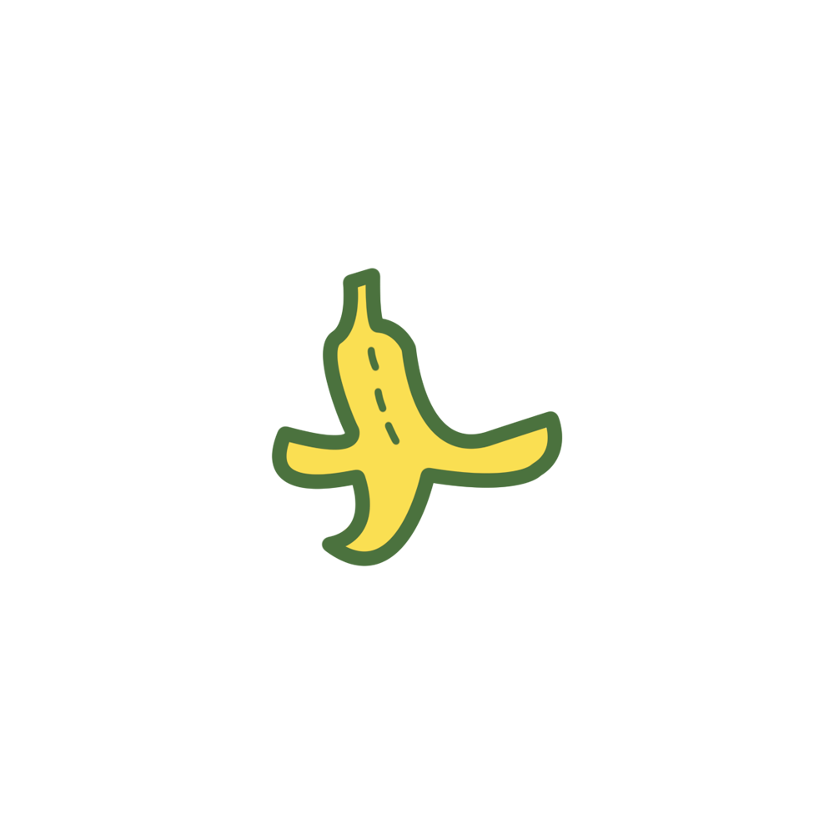
* **Banana peel**: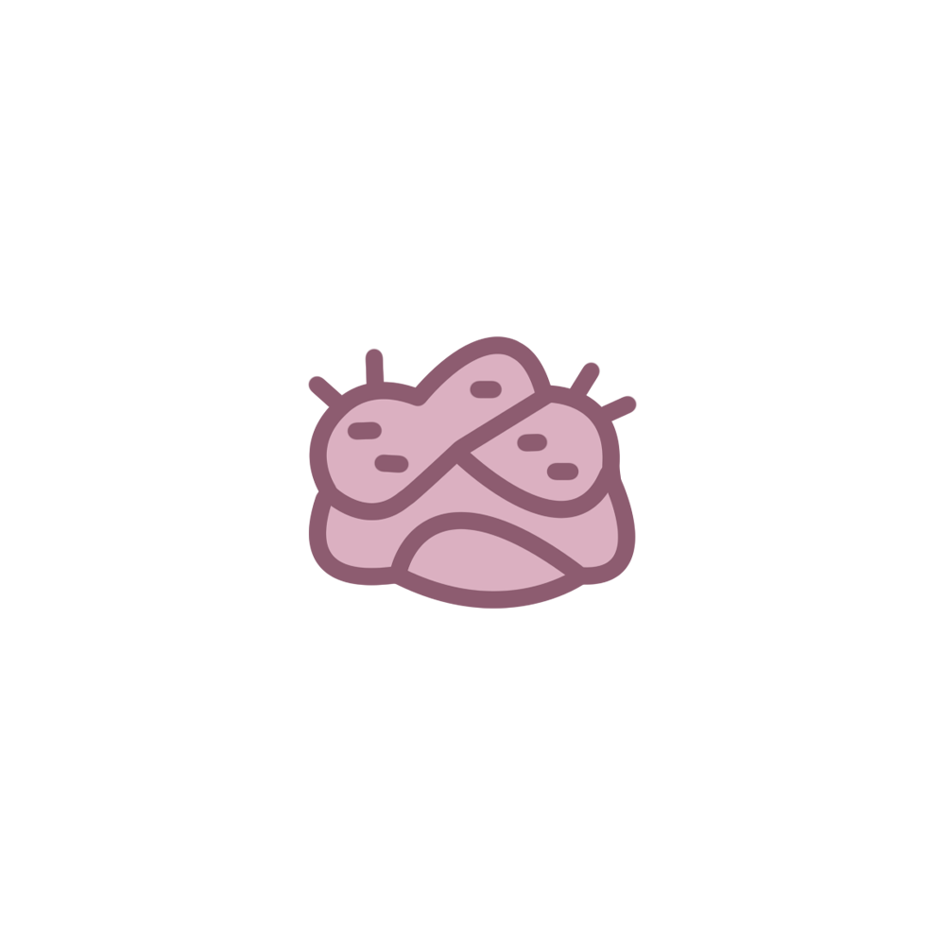



* **Chewing-Gum**:

* **Opened Can**: 
* **Fishbones**:

* **Waste paper**: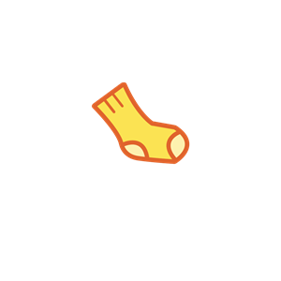

* **Sock**: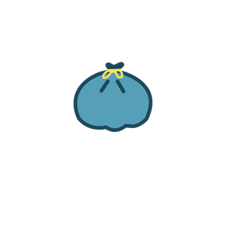
* **Thrash**:

### 

### 8.4.2 Stage 2

Stage 2 increases the difficulty adding a new movable block in order to create even more possibilities of level design.

### Items

* **Pizza**:

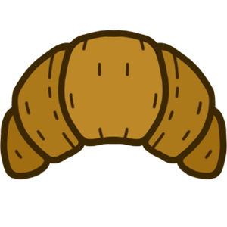

* **Croissant**:



* **Bratwurst**:

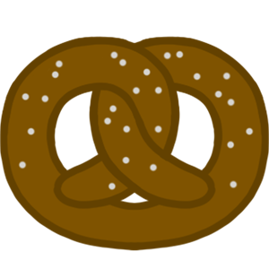

* **Brezel**:

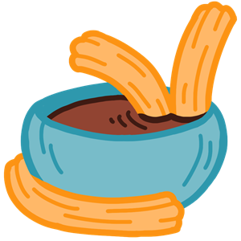

* **Churros**:

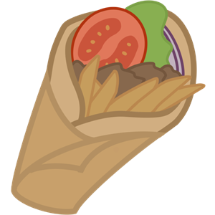

* **Gyros**: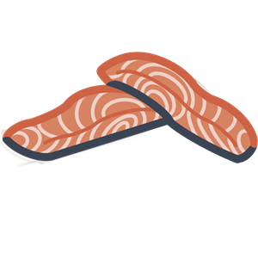

* **Norwegian Salmon**:

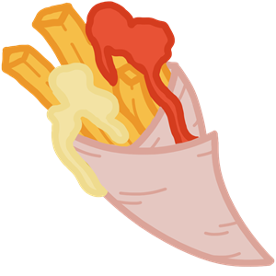

* **Dutch Potatoes**:

### 8.4.3 Stage 3

Stage 3 increases the number of blocks that the player is provided and pushes them to a more logical thinking.

### Items

* **Lucky Cookie**: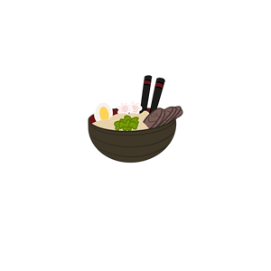

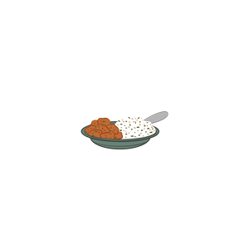

* **Ramen Bowl**:

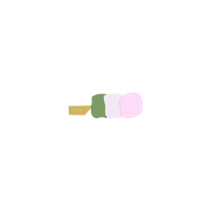

* **Chicken Curry**:

* **Sanshoku Dango**: 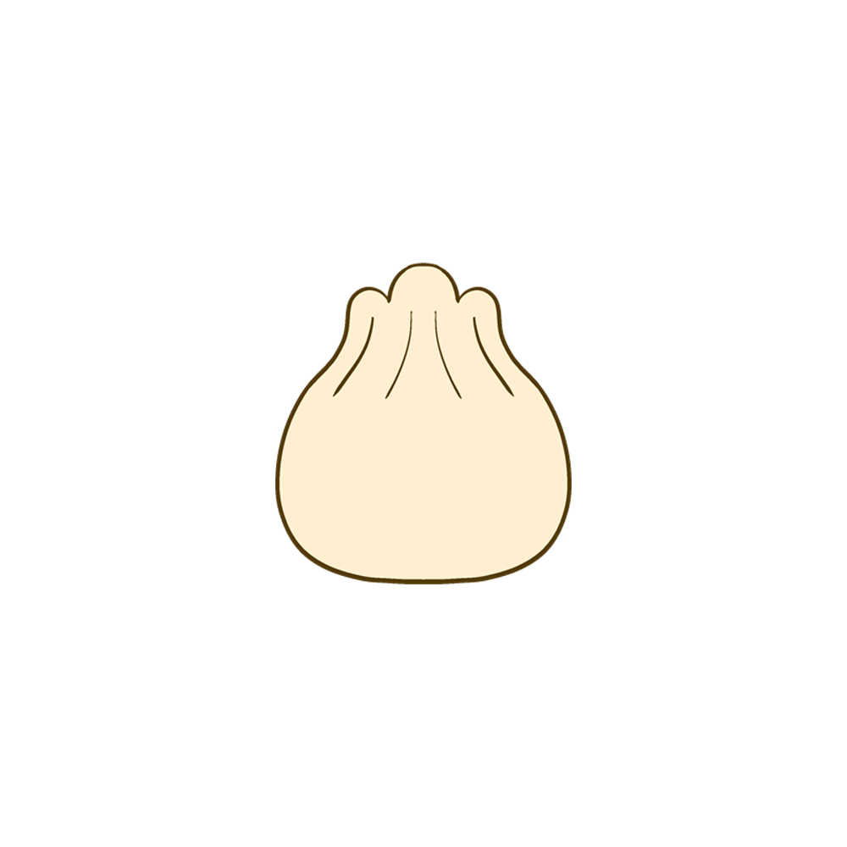

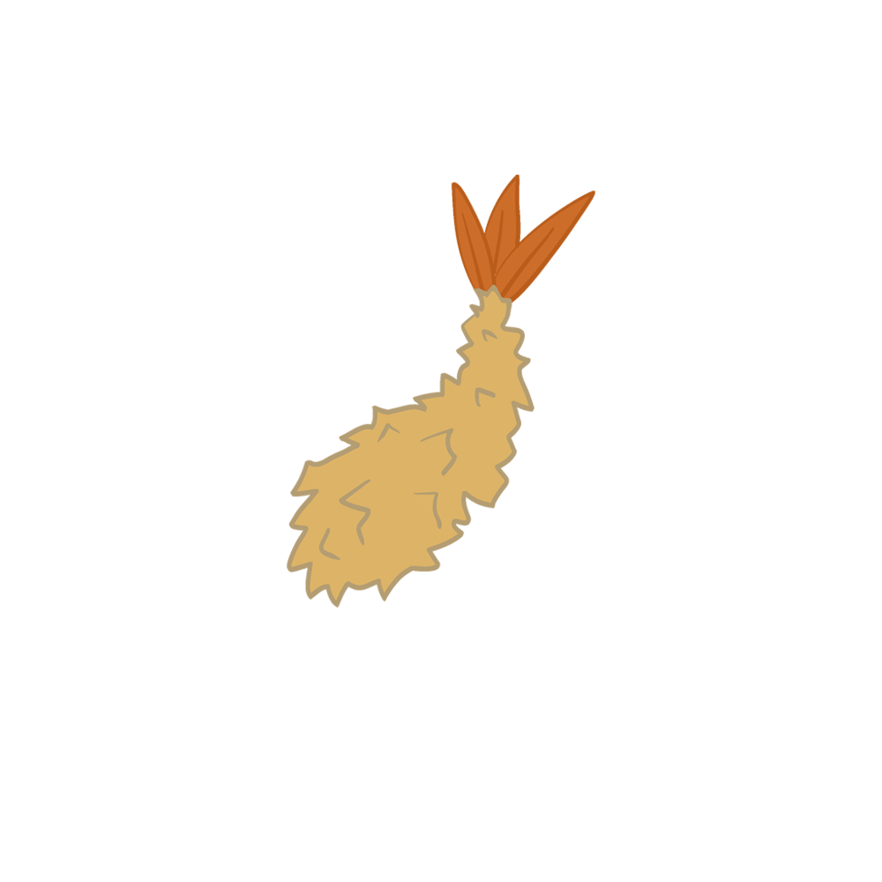

* **Bao**:

* **Tempura:**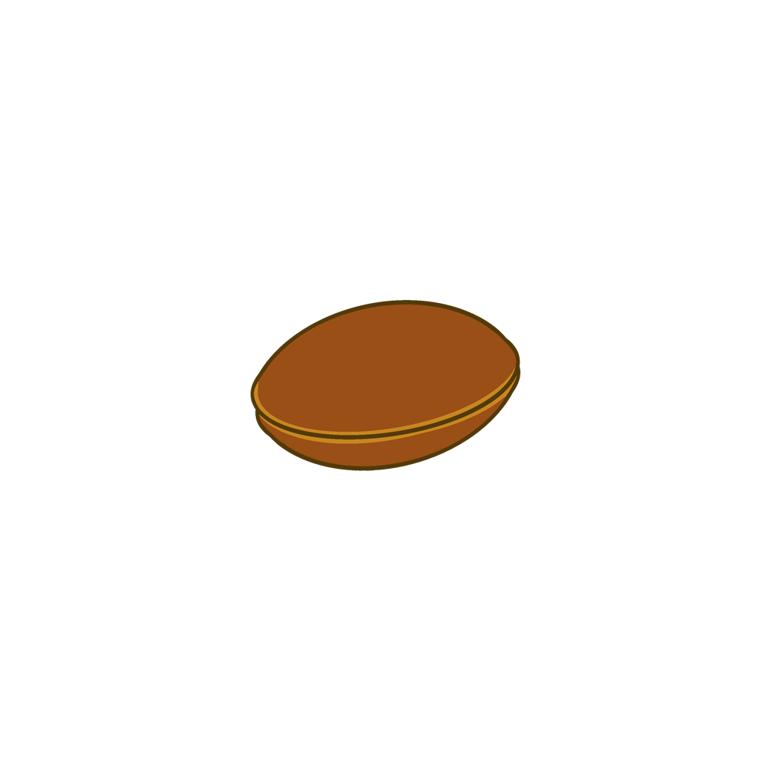

* **Dorayaki**: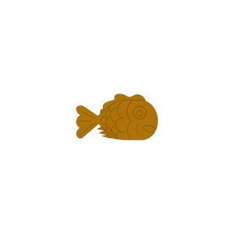
* **Taiyaki**:

### 8.4.4 Stage 4

Stage 4 pushes the player to think outside the box and these levels will make the player understand that the blocks can be stacked in a non-obvious way to create paths.

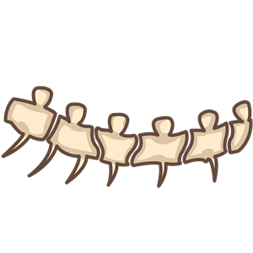

### Items

* **T-Rex Tail part 1**: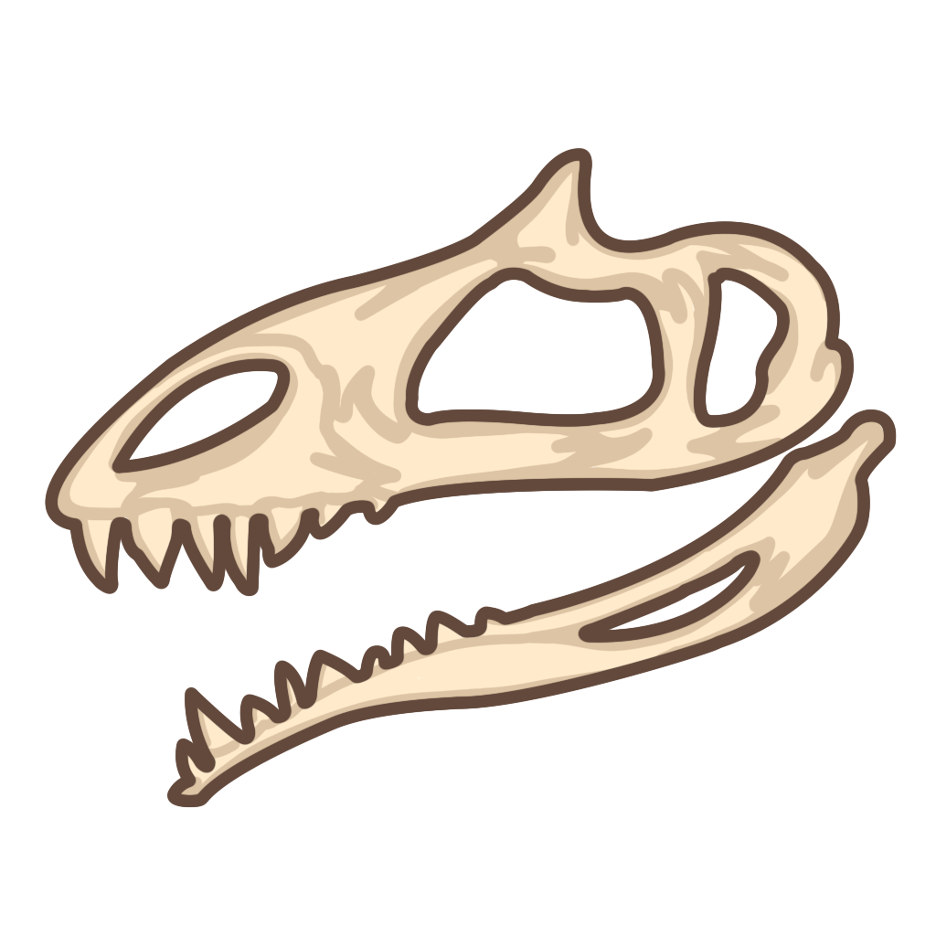
* **T-Rex Skull**: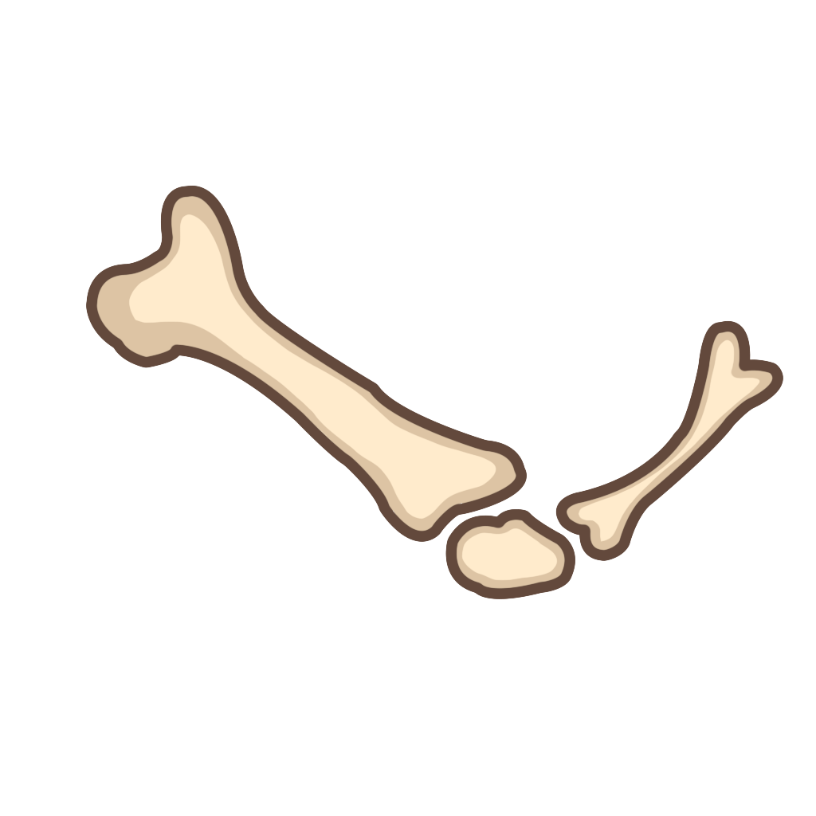
* **T-Rex Right Arm**: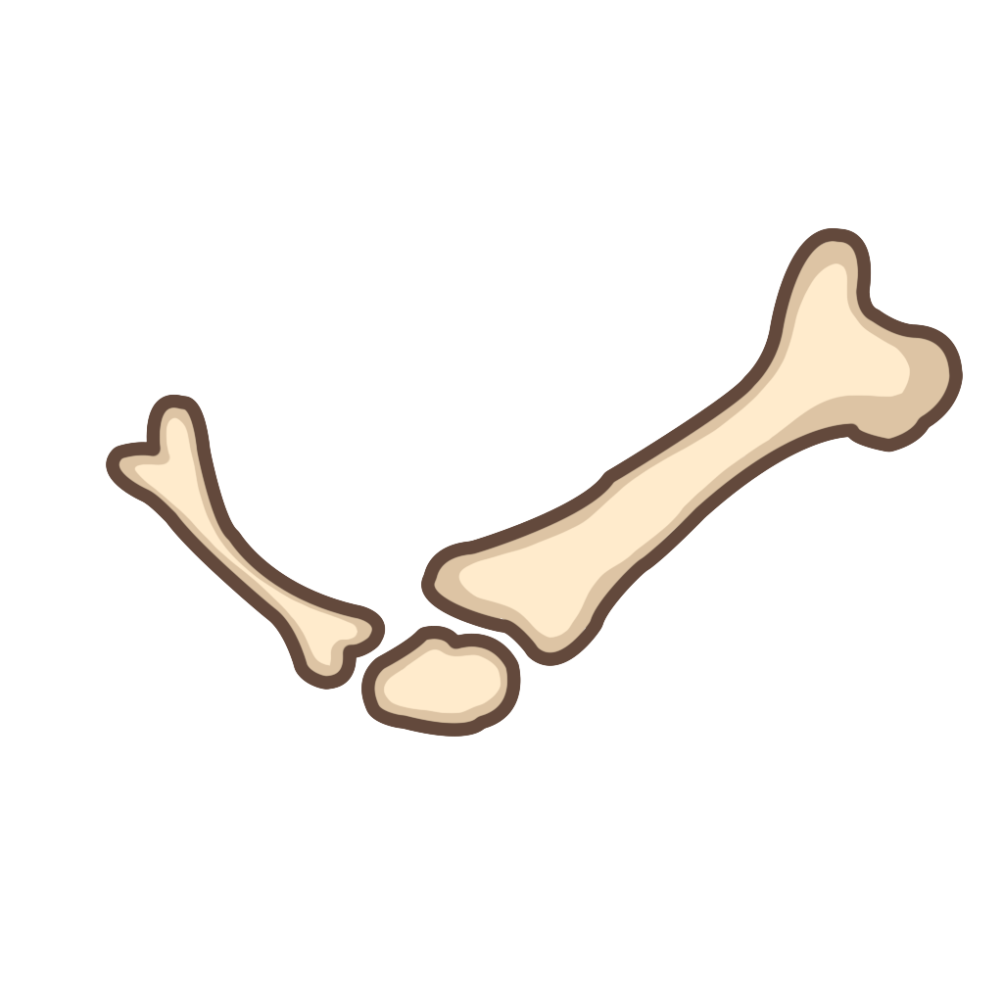

* **T-Rex Left Arm**:

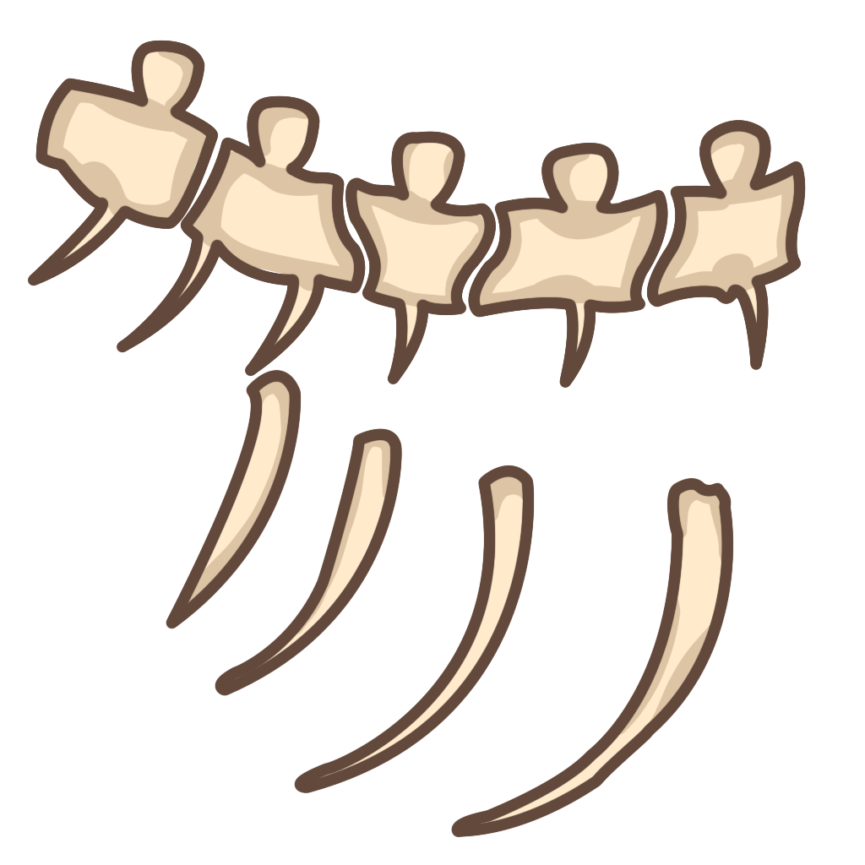

* **T-Rex Spine**:

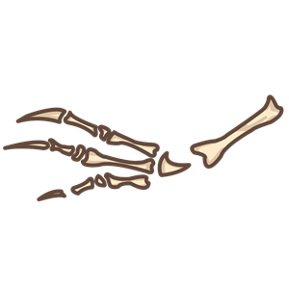

* **T-Rex Right Leg**:

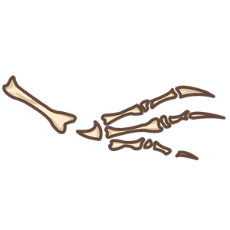

* **T-Rex Left Leg**: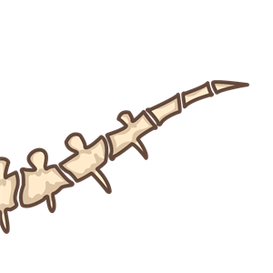
* **T-Rex Tail part 2**:

### 

### 8.4.5 Stage 5

Stage 5 is the last stage of the game. These levels are to be completed pushing the limits of the blocks and the grid, placing and stacking them in the most creative way possible.

### Items

* **Red Fish**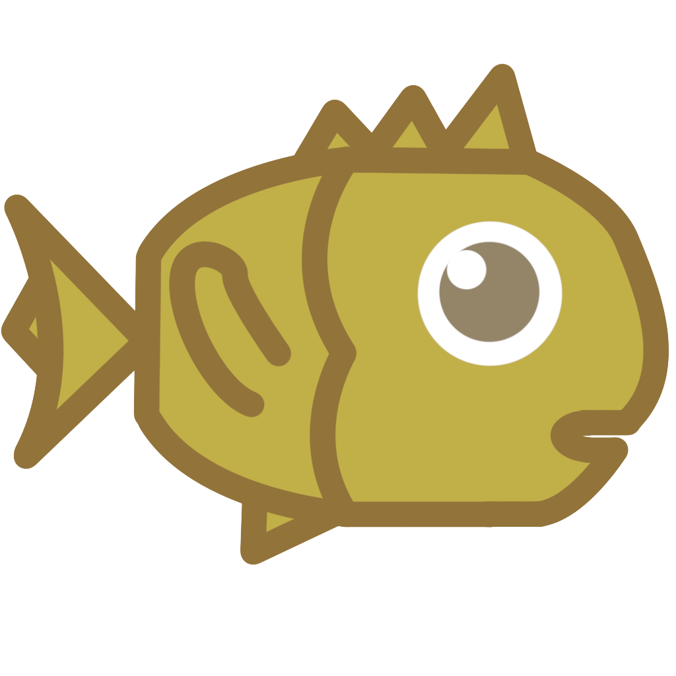
* **Yellow Fish**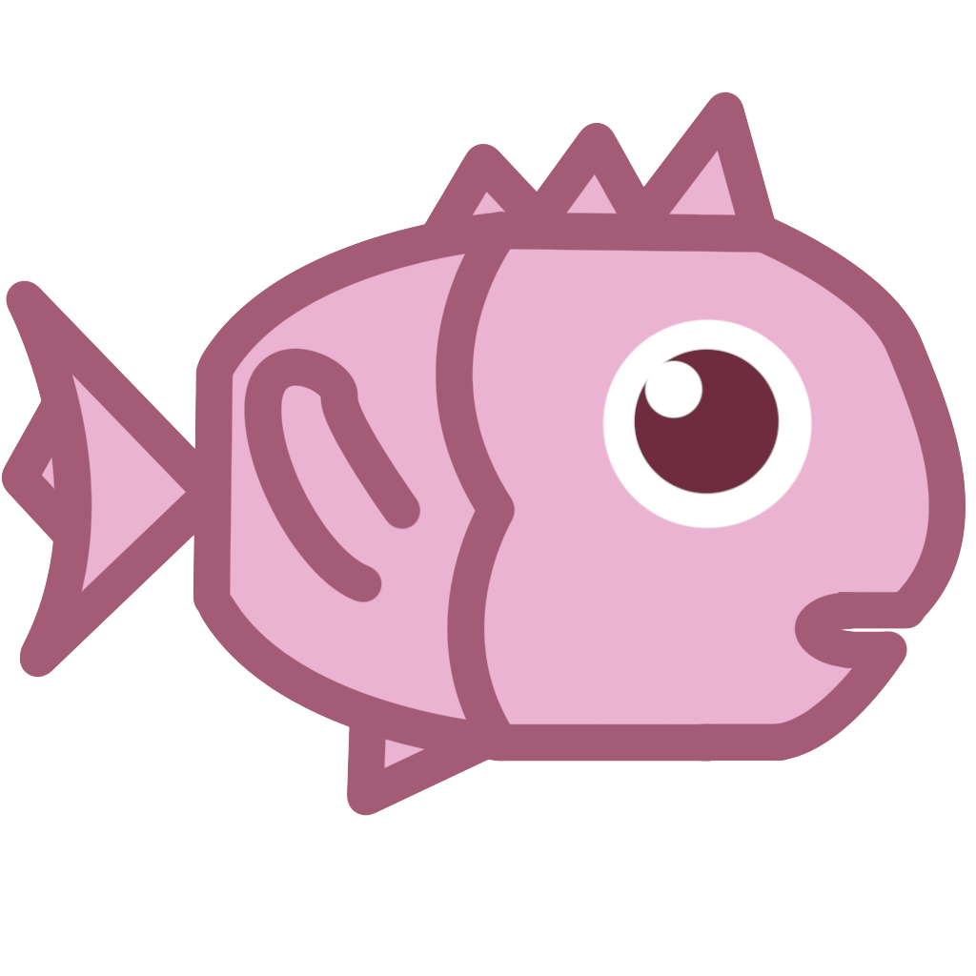
* **Pink Fish**
* **Blue Fish**
* **Purple Fish**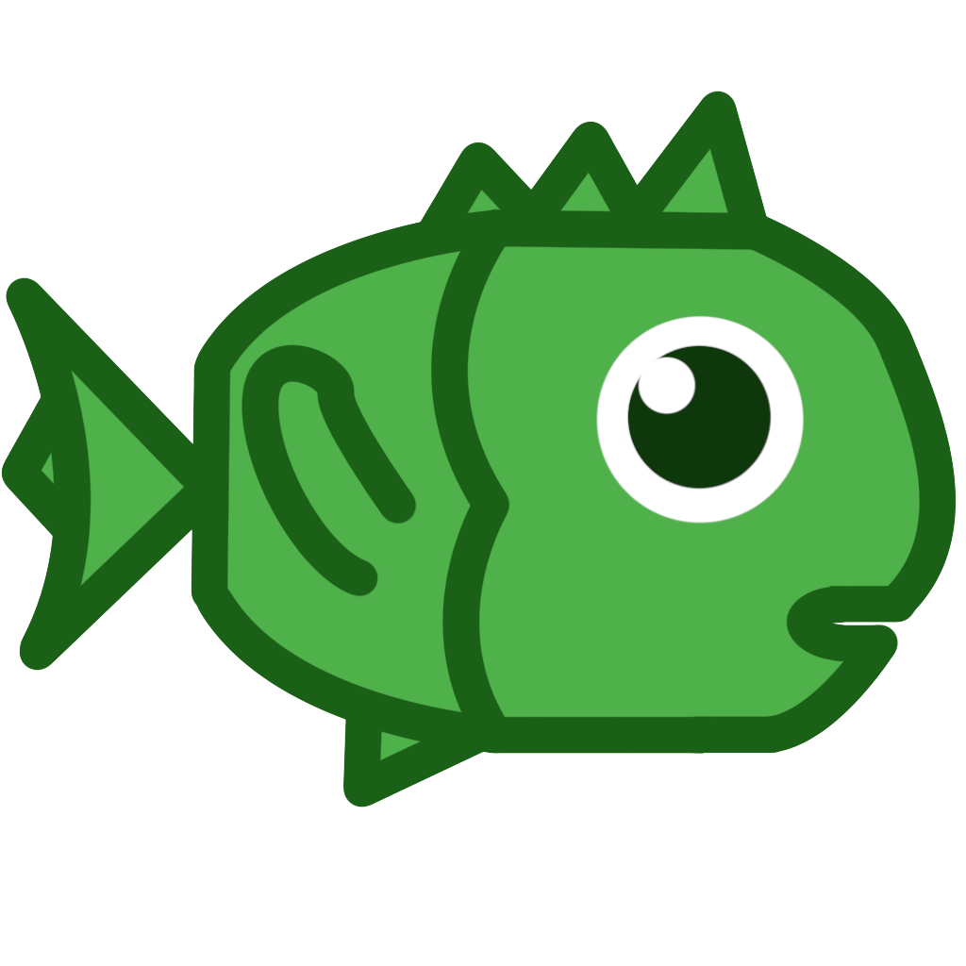
* **Green Fish**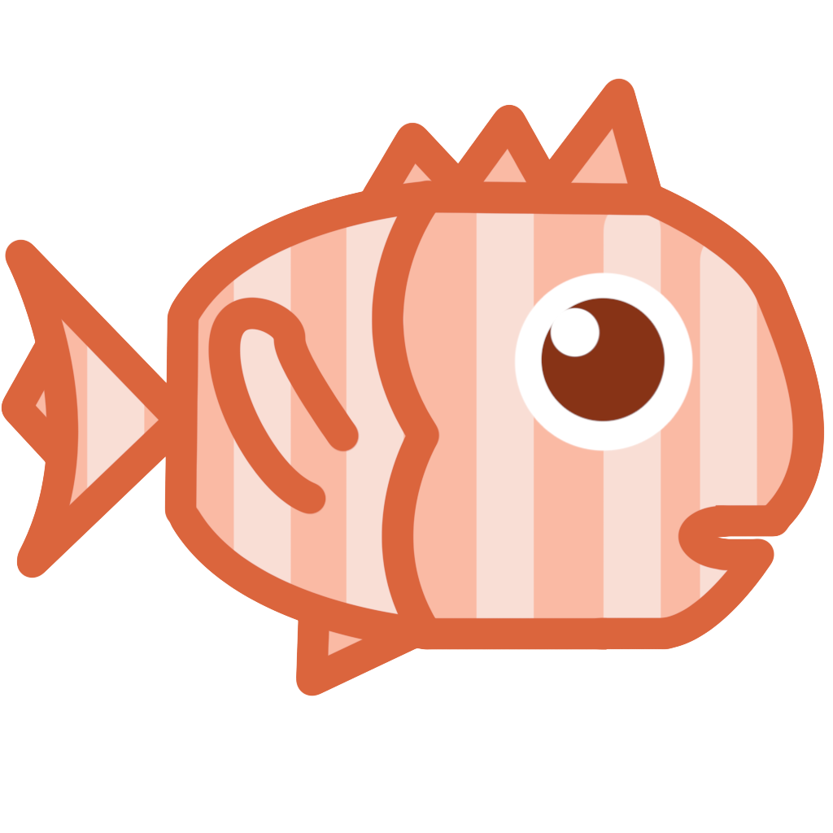
* **Orange/White Fish**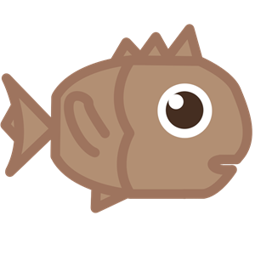
* **Brown Fish**

# 9.0 Graphical User Interface

At all times during the game, in the upper right corner of the screen, there will be a Home Button. The player can interact with this button at any given time, allowing them to exit the level and return to the level selecting screen, from which they can choose to start another level from any stage or return to the Main Menu.

## 9.1 Main Screen

When the player opens the application, the game starts.

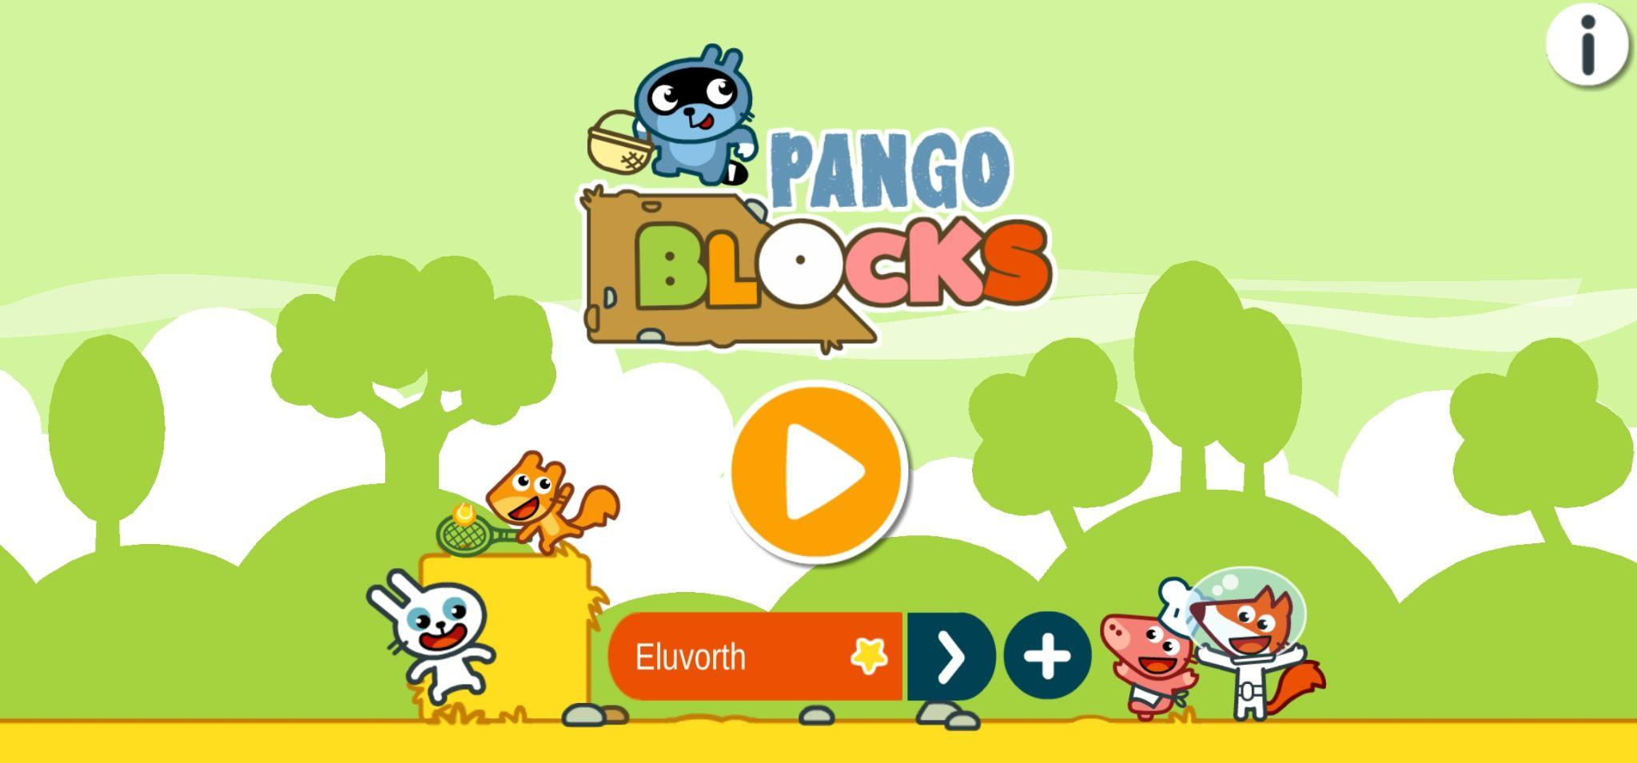

## 9.2 Menu Buttons

### 9.2.1 Play

The Play button is the largest one present in the game, the player will find it once the main game screen is started.

is orange in color with a white symbol and outline, has slight shading and also widens and narrows in the menu.



### 9.2.2 Info

The info button is located on the game's home screen in the upper right corner. Once pressed, the player has the option to view the development team with the names of the people who worked on the project and the game logo. is white in color with a dark gray symbol and light shading.



### 9.2.3 New Game

The New Game button appears next to the colored string where the player's name will appear.

The player can generate up to 5 save slots, each with its own modifiable difficulty.



### 9.2.4 Difficulty Buttons

The difficulty of the game is marked in the user profile creation panel, represented by one star if the difficulty is easy and two stars if the difficulty of the levels is difficult.



### 9.2.4a Lock

The Lock button is located above the icons of levels not yet unlocked by the player.

Once the player has completed a level, this button disappears and in its place appears the green icon of the key object of the level not yet completed.



### 9.2.4b Unlock

The unlock button is not interacting but is present in the pre-stage selection.

Once the player has completed the level, the green icon will be replaced by the icon of the key object obtained in that particular level.

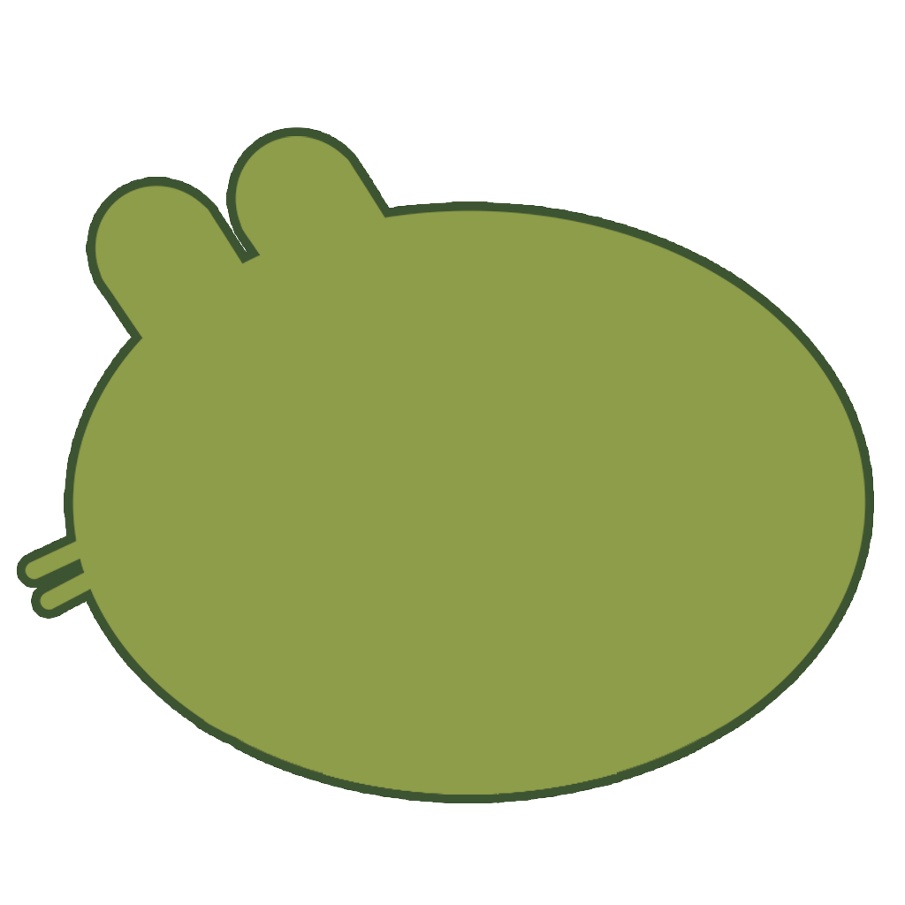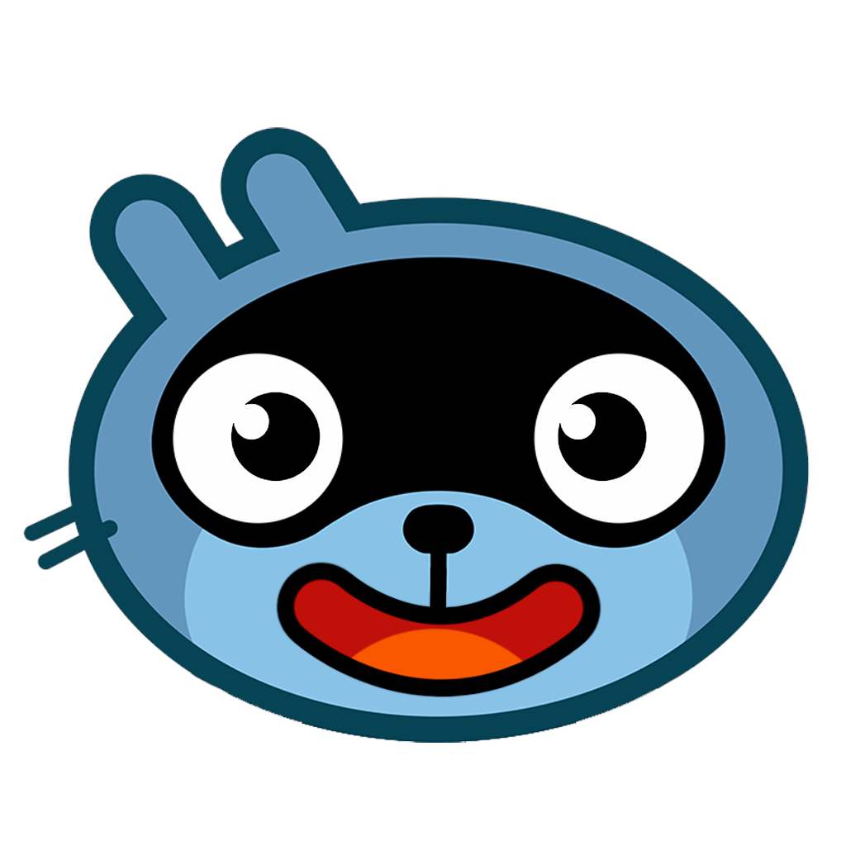

### 9.2.5 Arrows

The white arrows are used to scroll between stages in the stage selection menu.

### 

### 9.2.6 Arrow Skip

This arrow button has the function, when pressed, of taking the player to the next cutscene animation scene.

### 

### 9.2.7 Home

The home button is present within each level, in the upper right corner to allow the player to exit the level at any time.

The home button is also present in the stage selection menu and is used to take the player to the main menu.



## 

## 9.1 Main Menu

The main menu consists of several mechanics:

* **Saving game profiles**: it features a colored plate containing the user name and selected difficulty.

Each user profile saves all the data from levels unlocked on both easy and hard difficulties.

A plus button appears next to the section with the user name so that more profiles can be added. The maximum is 5 profiles, having reached the maximum capacity the plus button disappears.

* **Profile creation screen:** the player can create a profile whose name must not contain spaces and there must not already be another profile with the same name, and choose the difficulty with which to start this save.
* **Profile editing screen**: in this mode the name can be changed but it cannot contain spaces and there must not already be that name.

The player can delete user profiles created on the edit page.

When the play button is pressed for the first time, it will open the user profile creation screen, and this will repeat until one is created.

* **Stage Selection:** Once the play button is pressed, the player will be in the stage selection to play.

When the player loads the next stage, it will appear as completed with the full icon

Once all levels are completed, the full icons will appear instead of the green icons with the padlock, and the player will be able to select the cutscene or move on to the next stage.

* **Level Selection**: Each level is divided into three sprites (two sprites and a padlock on top) and each button controls that the corresponding level is completed or only unlocked.

When the player will be at the last level of the stage, if he has completed the previous levels the cutscene will start, otherwise he will be taken to the missing level.

When the player presses the cutscene button in the stage section, if there are missing levels it will indicate those, otherwise it will load the cutscene.

## 9.2 Loading Screen

* **Smooth transitions**: The camera transitions smoothly from one section or area of the game to another via a short loading screen.

For the main loading screen we have two types of animation:

* **Closing animation**: It occurs, with a random animation, every time there is a scene change, when the win condition is reached, and when returning to the main menu.
* **Opening animation**: It is random animation and goes to reopen the game scene, when the player starts the level, when the player goes to the next level, and when the player finds himself at the main menu.

Within the game there is also an orange loading screen with unique animation that appears when the player misplaces the block and creates a path that cannot be traveled by the character.

This screen re-opens the scene and the player finds the character at the initial position and the blocks at the position previously indicated by the player.

## 9.3 Cut Scenes

The cutscenes are divided into different animations.

At each division the animated characters will go to an idle position and the button to go to the next section of the animation will appear at the end of the cutscene the level selection menu will load.

After the player clears all eight levels of each stage, a cutscene will play.

The style of cutscenes is comic cartoon panels.

The stage one contains the original animations of the game, from stage two to stage five we have made the panels non-animated and with unique scenery, keeping the comedy and art style.

### 9.3.1 Cutscene Stage 1

Pango is collecting all the trash he can find on the ground and when he’s gathered a bunch, he throws it all away in a trash can. After a brief pause where Pango is happy to be done with his work, the trash can starts moving: it’s Piggy! He was playing a prank on Pango who is now very scared, while Piggy laughs happily.

### 9.3.2 Cutscene Stage 2

Pango comes back home from his trip to Europe and is happy to share with Piggy all the local food he brought back.

***Scene 1***: We are in Piggy's house.

Piggy (dressed as a Tyrolean) is greeting his friend Pango, who is coming through the door with a basket in his hand. Out of the basket come the collected items from Stage 2.

***Scene 2***: Focus on the table set with some of the dishes collected during his trip to Europe.

***Scene 3***: Pango and Piggy sitting at the table happily enjoying the day.

### 9.3.3 Cutscene Stage 3

Pango goes to visit her Japanese friend Fox and is fascinated by her country.

***Scene 1***: Fox stands on the red bridge looking at the view.

***Scene 2***: Fox and Pango see each other and greet each other with a typical Japanese greeting.

***Scene 3***: Fox is very happy about his dear friend's visit and Pango takes beautiful pictures of the scenery to capture the moment.

### 9.3.4 Cutscene Stage 4

Pango decides to help his archeologist friend Bunny with her studies and, after exploring the desert, he brings her all the fossil bones of a T-Rex.

***Scene 1***: Bunny is at the museum working. He is very focused.

***Scene 2***: Pango enters the museum with a cart, carrying the missing pieces of the t-rex and causing Bunny to gasp in amazement.

***Scene 3***: Pango and Bunny happy after assembling the dinosaur in its entirety.

### 9.3.5 Cutscene Stage 5

Pango goes on a fishing spree and when he’s happy with his loot, he brings it all to Squirrel and they share a happy moment.

## 

## 9.4 Controls

**Input methods:** *Touch screen gesture*.

The player can drag an item by dragging it across the screen, holding it down with one finger, and releasing it once it is placed in the desired position with a one-touch gesture.

## 9.5 Input Characters

With a single tap, the player can tap the screen over the character or over the end goal item and the character will begin the predetermined movement.

# 10.0 Audio

There are several audio tracks in the game.

The audio tracks are Stereo (2D) clips and are divided into 3 categories:

* *Soundtrack* is concurrent and will have only one source of its own from which to start.
* *Sound Effects* have multiple sources to start from and compete with each other.
* *UI SFX* will have only one source from which it starts and do not compete with the other sources

## 10.1 Soundtrack

The Soundtrack is not concurrent, there is a background track and the audio clip will be overlaid.

There will be an audio track as soon as the game starts and throughout the period that the player spends in the menus

There will be an equal audio track for all levels that will accompany the player throughout the gameplay.

This will be interrupted only when the cutscenes are played.

## 10.2 Sound Effects

Sound Effects are divided into two categories, SFX and Effects for UI.

* **SFX**: They have multiple sources to start from (describe the tracks and when they should start).
* **UI SFX**: These are concurrent tracks in the menus.

Sound effects are present throughout the game to make the main character's movements such as walking, sliding, interactions with npc's in cutscenes, and for all the interacting blocks to create his path more realistic.

Some effects are also present to give negative auditory feedback to the player when, for example, he places a block within the grid in an invalid position.

The sound effects for the UI, on the other hand, are intended to actively guide the player throughout his or her time within the game menus.

# 11.0 Team

## Game Designer

Cavallari Sharon

Guerra Valeria

## Game Programmer

Faraci Denis

## Game Artist

Agosti Federico

Avanzi Nicole

Esposito Manuel

Gandini Sara

Pesce Letizia

Rindone Francesco

Rizzo Paolo

Schiavi Marika

Timeo Giulia